Refugee Portal Technical Specifications

# RefugeePortal

The project is mainly Thymeleaf but the implementation is creating static translation jsps per page (that’s what I tried not to follow)

Security check is applied using

com.refugees.filters.UserSecurityFilter (Nammin User New Implementation)

net.hitachifbbot.filter.RequireNamminLoginFilter(Nammin User Old Implementation with minor changes)

net.hitachifbbot.filter.RequireDoctorLoginFilter (Doctor Old Implementation)

## Nammin User

### landing page

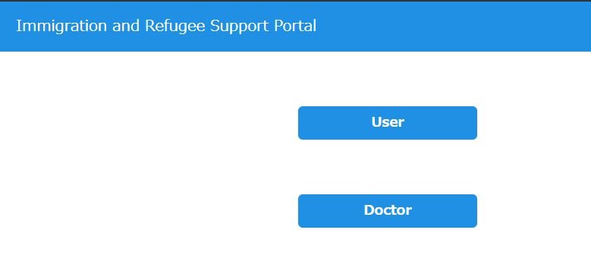

Is mainly welcome.html (just welcome page)

### User Home

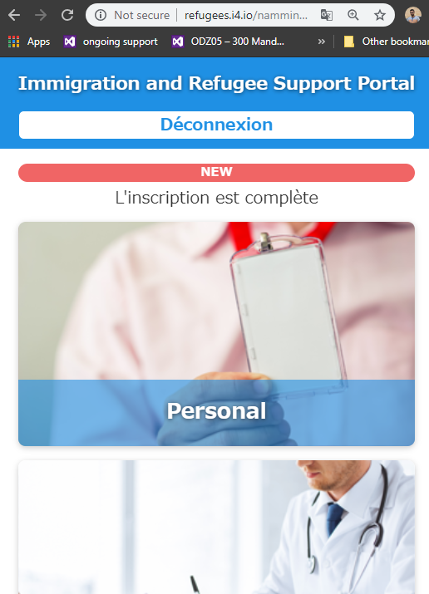

The original JSP is under /RefugeePortal/src/main/webapp/WEB-INF/jsp/nammin/_original/portal.jsp

Logic is under /RefugeePortal/src/main/java/net/hitachifbbot/servlet/NamminPortalServlet.java

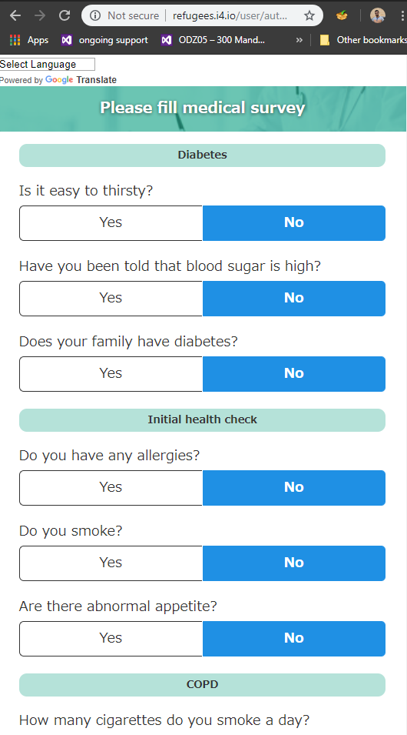

This is /RefugeePortal/src/main/webapp/WEB-INF/jsp/user/home.jsp

Logic is under /RefugeePortal/src/main/java/com/refugees/servlets/user/UserHomeServlet.java

Registeration page is added

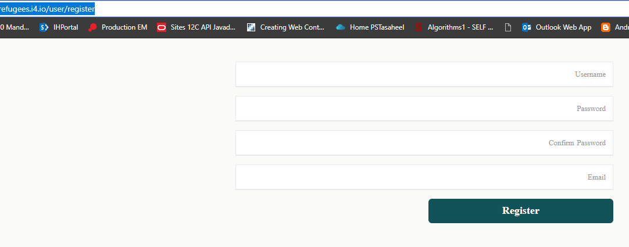

/RefugeePortal/src/main/webapp/WEB-INF/jsp/user/register.jsp

Logic is under /RefugeePortal/src/main/java/com/refugees/servlets/user/UserRegisterationServlet.java

## Doctor

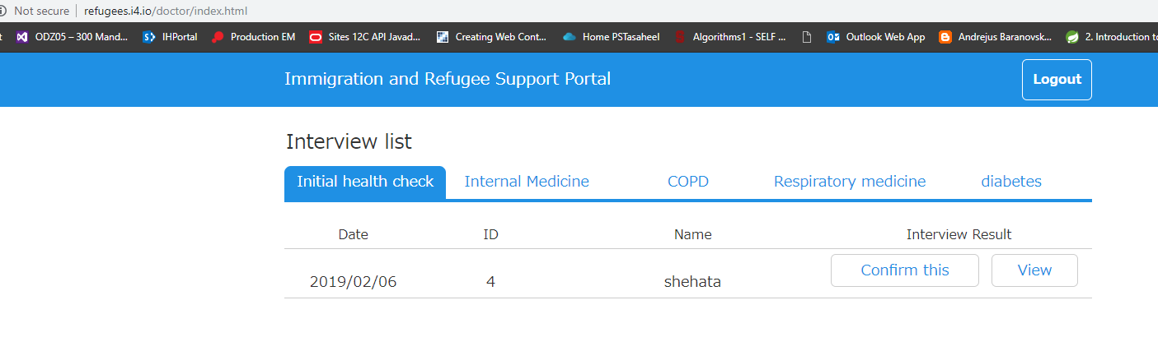

This is the main landing screen and this is

/RefugeePortal/src/main/webapp/WEB-INF/jsp/doctor/screening_list.jsp

And the logic is under /RefugeePortal/src/main/java/net/hitachifbbot/servlet/DoctorIndexServlet.java

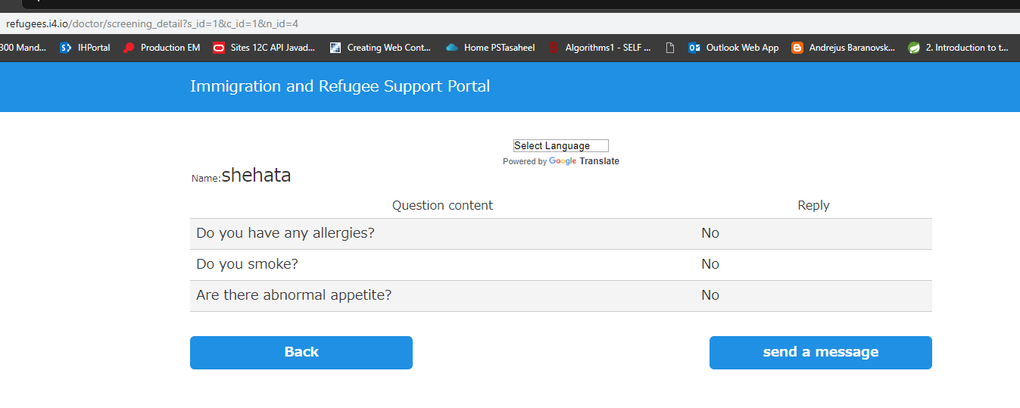

This is mainly

/RefugeePortal/src/main/webapp/WEB-INF/jsp/doctor/personal_details.jsp

And the logic is under

/RefugeePortal/src/main/java/com/refugees/servlets/doctor/ScreeningDetailServlet.java

The rest added is Data Access layer for the database

# FacebookChatbot

The application consists of 3 main parts

1. Database
   1. Model
   2. Repositories
   3. Service
2. Controllers
   1. ChatbotCallBack which is the facebbok webhook
   2. MessageController which sends messages from external application using the callback so at least send It one message to initiate
3. Translator which is the Google Translate integration part

From google console you need to generate API key

<https://console.cloud.google.com>

and set it’s value under system property GOOGLE_API_KEY

for facebook chatbot

* 1. create page
  2. create Facebook application
  3. register the messaging webhook
  4. request message permission and submit all required documents

once approved you now have the chat bot ready

For the two deployments you need to create datasource with the JNDI name java:/jdbc/portal

For the portal database